`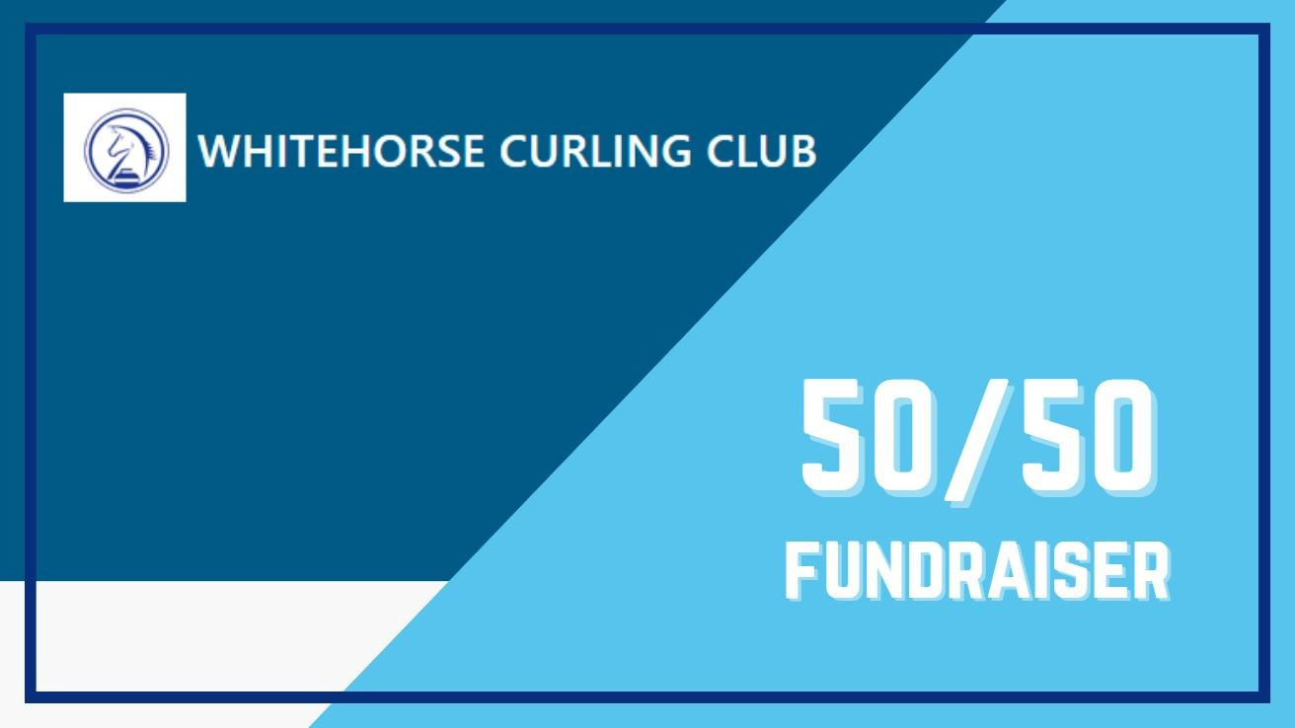

SUPPORT YOUR CLUB WITH OUR ONLINE 50/50 RAFFLE

BEGINS: March 24, 2025

ENDS: May 16, 2025

DRAW DATE: June 3, 2025

**Ticket Prices:**

**1 for $10 3 for $20 8 for $50 20 for $100**

**Tickets Available Online at Rafflebox – Raffle #74355**

Or Use the QR Code here: 

License # 2025-042